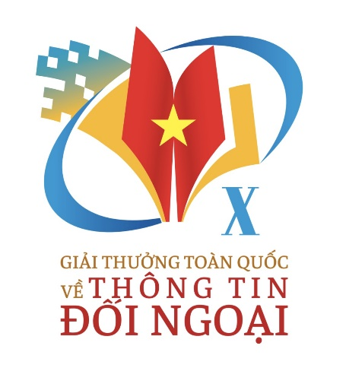 | PRESS RELEASE  10th National External Information Service Awards

The Steering Committee for External Information Affairs, the Party Central Committee’s Commission for Information and Education, and the Vietnam Television will organize the Launching Ceremony of the 10th National External Information Service Awards on March 28th, in Hanoi.
The Awards aim to honor outstanding forces in the external information sector. It will also motivate and encourage collectives and individuals to actively participate in external information dissemination and promote the image of Vietnam's land, people, culture, and intellect to the world, and vice versa through external information works and products.
The year 2024 marks the 10th anniversary of the establishment of the National External Information Service Awards. It is also one of the key tasks being carried out, following Conclusion No. 57-KL/TW, dated June 15, 2023, of the Politburo on further enhancing the quality and effectiveness of external information work in the new situation. After 10 years, the Awards have been increasingly expanded, innovated, and adapted to the growing diversity of works/products in the external information field. This has also helped the Awards attract a diverse range of participating authors or groups of authors, from journalists to researchers, artists, students, overseas Vietnamese, and foreigners.
The 10th National External Information Service Awards will evaluate external information works/products in the following categories: (1) Video Clip; (2) Initiatives, products contributive to external information service; (3) Photos; (4) Television; (5) Radio; (6) Books; (7) Printed newspapers in Vietnamese; (8) E-newspapers and information websites in Vietnamese; (9) Printed newspapers in foreign languages; (10) E-newspapers and information websites in foreign languages.
Submissions must be published on mass media, released, distributed, announced, implemented, or organized domestically and internationally from July 1, 2023, to June 30, 2024. For works/products released before or after this period, two-thirds of the work’s content must be published during the stipulated period to be qualified.
This year, the Organizing Committee encourages authors/groups of authors to submit entries in digital format, sent to the email address:
giaithongtindoingoai10@gmail.com
For categories of printed products such as books and newspapers in Vietnamese and foreign languages, please send them to the address:
Vietnam Television Office, 43 Nguyen Chi Thanh, Ba Dinh District, Hanoi
Phone: 02437714353
Entries must be submitted before July 31, 2024.
In 2023, the Organizing Committee of the 9th National External Information Service Awards received 1,456 entries. The award ceremony was held on the evening of October 12, 2023, at the Hanoi Opera House. The Award Council selected 110 outstanding submissions to be awarded, including 8 First, 22 Second, 30 Third, and 50 Consolation Prizes. Prime Minister Pham Minh Chinh attended and delivered a speech at the ceremony.

